In [1]:

pip install seaborn

Requirement already satisfied: seaborn in c:\users\hp\anaconda3\lib\site-packages (0. 9.0)

Requirement already satisfied: matplotlib>=1.4.3 in c:\users\hp\anaconda3\lib\site-pac kages (from seaborn) (3.1.1)

Requirement already satisfied: numpy>=1.9.3 in c:\users\hp\anaconda3\lib\site-packages (from seaborn) (1.16.5)

Requirement already satisfied: scipy>=0.14.0 in c:\users\hp\anaconda3\lib\site-package s (from seaborn) (1.3.1)

Requirement already satisfied: pandas>=0.15.2 in c:\users\hp\anaconda3\lib\site-packag es (from seaborn) (0.25.1)

Requirement already satisfied: cycler>=0.10 in c:\users\hp\anaconda3\lib\site-packages (from matplotlib>=1.4.3->seaborn) (0.10.0)

Requirement already satisfied: kiwisolver>=1.0.1 in c:\users\hp\anaconda3\lib\site-pac kages (from matplotlib>=1.4.3->seaborn) (1.1.0)

Requirement already satisfied: pyparsing!=2.0.4,!=2.1.2,!=2.1.6,>=2.0.1 in c:\users\hp

\anaconda3\lib\site-packages (from matplotlib>=1.4.3->seaborn) (2.4.2)

Requirement already satisfied: python-dateutil>=2.1 in c:\users\hp\anaconda3\lib\site- packages (from matplotlib>=1.4.3->seaborn) (2.8.0)

Requirement already satisfied: pytz>=2017.2 in c:\users\hp\anaconda3\lib\site-packages (from pandas>=0.15.2->seaborn) (2019.3)

Requirement already satisfied: six in c:\users\hp\anaconda3\lib\site-packages (from cy cler>=0.10->matplotlib>=1.4.3->seaborn) (1.12.0)

Requirement already satisfied: setuptools in c:\users\hp\anaconda3\lib\site-packages (from kiwisolver>=1.0.1->matplotlib>=1.4.3->seaborn) (41.4.0)

Note: you may need to restart the kernel to use updated packages.

In [2]:

**import** pandas **as** pd

**import** numpy **as** np

**import** matplotlib.pyplot **as** plt

**import** seaborn **as** sns

dataset **=** sns.load_dataset('titanic') dataset.head()

|  |  |  |  |  |  |  |  |  |  |  |  |  |  |  |
| --- | --- | --- | --- | --- | --- | --- | --- | --- | --- | --- | --- | --- | --- | --- |
| Out[2]: |  | | | | | | | | | | | | | |
|  |  | **survived** | **pclass** | **sex** | **age** | **sibsp** | **parch** | **fare** | **embarked** | **class** | **who** | **adult_male** | **deck** | **emb** |
|  | 0 | 0 | 3 | male | 22.0 | 1 | 0 | 7.2500 | S | Third | man | True | NaN | Sou |
|  | 1 | 1 | 1 | female | 38.0 | 1 | 0 | 71.2833 | C | First | woman | False | C | C |
|  | 2 | 1 | 3 | female | 26.0 | 0 | 0 | 7.9250 | S | Third | woman | False | NaN | Sou |
|  | 3 | 1 | 1 | female | 35.0 | 1 | 0 | 53.1000 | S | First | woman | False | C | Sou |
|  | 4 | 0 | 3 | male | 35.0 | 0 | 0 | 8.0500 | S | Third | man | True | NaN | Sou |

In [3]:

sns.distplot(dataset['fare'])

Out[3]: <matplotlib.axes._subplots.AxesSubplot at 0x2367329efc8>

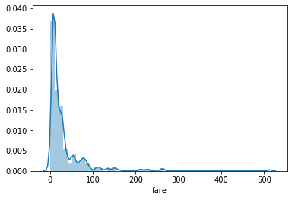

In [4]:

sns.distplot(dataset['fare'], kde**=False**)

Out[4]: <matplotlib.axes._subplots.AxesSubplot at 0x236736415c8>

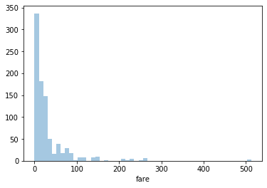

In [5]:

sns.jointplot(x**=**'age', y**=**'fare', data**=**dataset)

Out[5]: <seaborn.axisgrid.JointGrid at 0x23673741888>

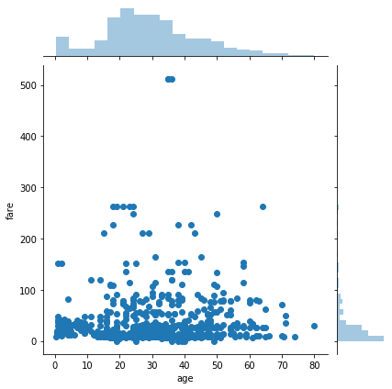

In [6]:

sns.rugplot(dataset['fare'])

Out[6]: <matplotlib.axes._subplots.AxesSubplot at 0x23673972c08>

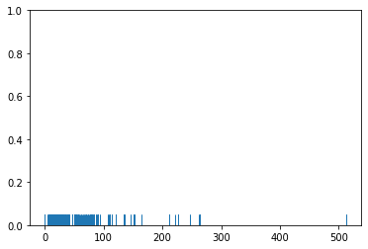

In [7]:

sns.barplot(x**=**'sex', y**=**'age', data**=**dataset)

Out[7]: <matplotlib.axes._subplots.AxesSubplot at 0x23673a2f648>

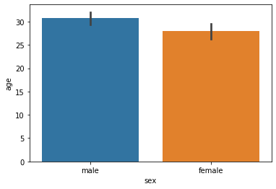

In [8]:

sns.countplot(x**=**'sex', data**=**dataset)

Out[8]: <matplotlib.axes._subplots.AxesSubplot at 0x2366d724a48>

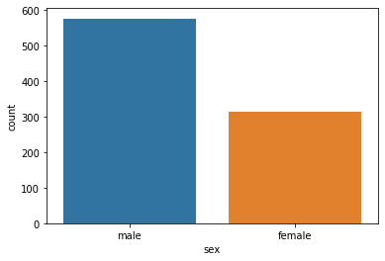

In [9]:

sns.boxplot(x**=**'sex', y**=**'age', data**=**dataset)

Out[9]: <matplotlib.axes._subplots.AxesSubplot at 0x23673afc208>

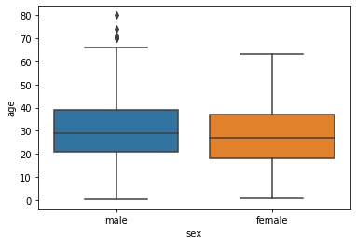

In [10]:

sns.boxplot(x**=**'sex', y**=**'age', data**=**dataset, hue**=**"survived")

Out[10]: <matplotlib.axes._subplots.AxesSubplot at 0x23673b80508>

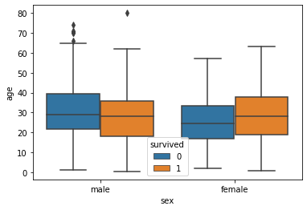

In [11]:

sns.violinplot(x**=**'sex', y**=**'age', data**=**dataset)

Out[11]: <matplotlib.axes._subplots.AxesSubplot at 0x23673c46e48>

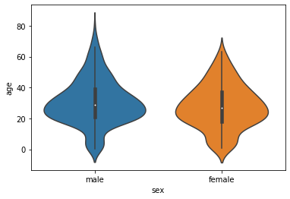

In [12]:

sns.stripplot(x**=**'sex', y**=**'age', data**=**dataset)

Out[12]: <matplotlib.axes._subplots.AxesSubplot at 0x23673ca1888>

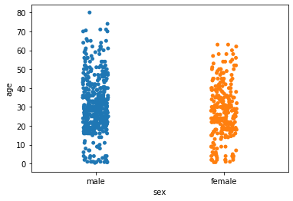

In [13]:

sns.swarmplot(x**=**'sex', y**=**'age', data**=**dataset)

C:\Users\HP\Anaconda3\lib\site-packages\seaborn\categorical.py:1324: RuntimeWarning: i nvalid value encountered in less

off_low = points < low_gutter

C:\Users\HP\Anaconda3\lib\site-packages\seaborn\categorical.py:1328: RuntimeWarning: i nvalid value encountered in greater

off_high = points > high_gutter

Out[13]: <matplotlib.axes._subplots.AxesSubplot at 0x23673d17488>

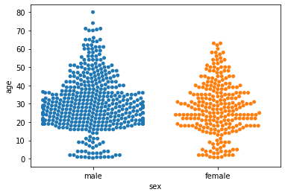

In [14]:

sns.violinplot(x**=**'sex', y**=**'age', data**=**dataset)

sns.swarmplot(x**=**'sex', y**=**'age', data**=**dataset, color**=**'black')

Out[14]: <matplotlib.axes._subplots.AxesSubplot at 0x23673dc5e48>

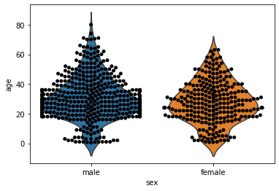

In [15]:

*#Expt. No. 8 Part-2 # histogram of fare*

titanic_hist **=** dataset.fare.plot.hist(bins **=** 40, color **=** 'grey') plt.xlabel('Fare (pounds, 1912 prices)')

plt.show(titanic_hist)

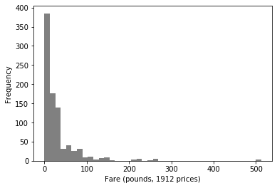

In [16]:

sns.distplot(dataset['fare'])

Out[16]: <matplotlib.axes._subplots.AxesSubplot at 0x23673c28d48>



In [ ]: